**DOCUMENTATION ON**

**PASCAL IMITATION JEWELLERY**



**STARTING DATE: 20-AUG-2023**

**ENDING DATE: 20-SEP-2023**

|  |  |  |
| --- | --- | --- |
| **Author** | | |
| **Name** | **ID** | **Email** |
| Arjan Das | 1456567 | [arjandaskhatri9@gmail.com](mailto:arjandaskhatri9@gmail.com) |
| Mohammad Usman | 1457280 | [zainusman2005@gmail.com](mailto:zainusman2005@gmail.com) |
| Yousuf Raza Youhana | 1453137 | [youhana932@gmail.com](mailto:youhana932@gmail.com) |

**Table of Contents**

1. Problem Statement
2. Introduction
3. Purpose of Documentation
4. Project Overview
5. Contact Information
6. Getting Started
7. Accessing Pascal Jewellers
8. Layout and Navigation
9. Product Details
10. Shopping Cart
11. Adding Items to Cart
12. Cart Management
13. User Account
14. Creating an Account
15. Account Management
16. Conclusion
17. Project Achievements
18. Acknowledgments

Problem Statement:

“PASCAL IMITATION JEWELLERY” is one of the leading manufacturers and suppliers of Precious, Semi precious and Artificial Jewelry. They sell them under different brand names. The Quality of the products are renowned for striking features such as smooth polish, stunning design and excelling clarity, look and feature, luster. The shop owner wishes to have the website of the jeweler shop where in they want to describe all the type, brands of the product.

**Requirement Specification:**

The Web site is to be created based on the following requirements.

1) The home page must describe the keywords or highlight of the shop along with all navigation link defined.

2) The product must be categorized as per the “Brand”.

3) It should be followed by sub-category with the type (Original, Semi Precious, and Artificial).

4) Proper description of the product along with the image must be added in the website.

5) Comparison of the product must be included in the website. (like comparison between product designing same but one will be semi-Precious and other Artificial and so on).

6) Contact Us

7) About Us

8) Feedback form

9) Gallery section should be added.

10) Color combination must be uniform throughout the project.

11) Navigation must be smooth.

Hardware/ Software Requirements

**Hardware**

* A minimum computer system that will help you access all the tools in the courses is a Pentium 166 or better 64 Megabytes of RAM or better
* Software [Either or Combination as per Course/Sem]
* Notepad/HTML editor/CoffeeCup
* Angular / Angular JS / React / BootStrap
* Dreamweaver / Figma
* MS IE / Chrome / FireFox / Netscape /MS Edge

DFD Diagram

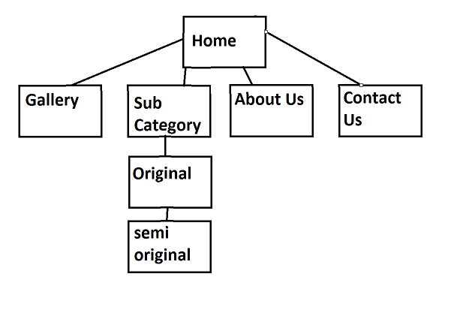

Introduction:

The Pascal Jewellery website is a web-based platform for users to browse, purchase, and learn about Pascal Jewellery products. The website is designed to be user-friendly and informative, and it offers a variety of features to help users find the perfect piece of jewellery for their needs.

Navigation:



Navigation within the Pascal Jewellers website is designed to provide users with an intuitive and user-friendly experience. The website's navigation is structured to help users easily access various sections, explore products, and complete their shopping journey efficiently.

**Main Navigation Menu**

The main navigation menu is located at the top of every page and includes the following sections:

**Home**

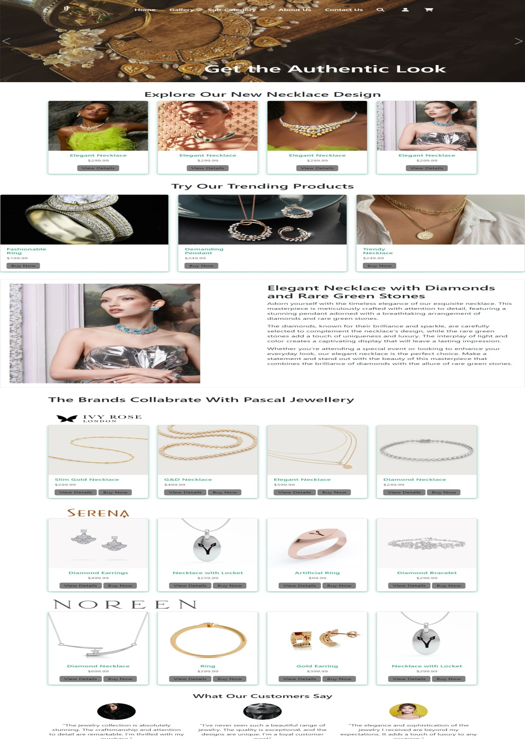

Description: The "Home" link takes users to the homepage of Pascal Jewellers.

Usage: Users can click on this link to return to the homepage from any other page on the website.

**Gallery**

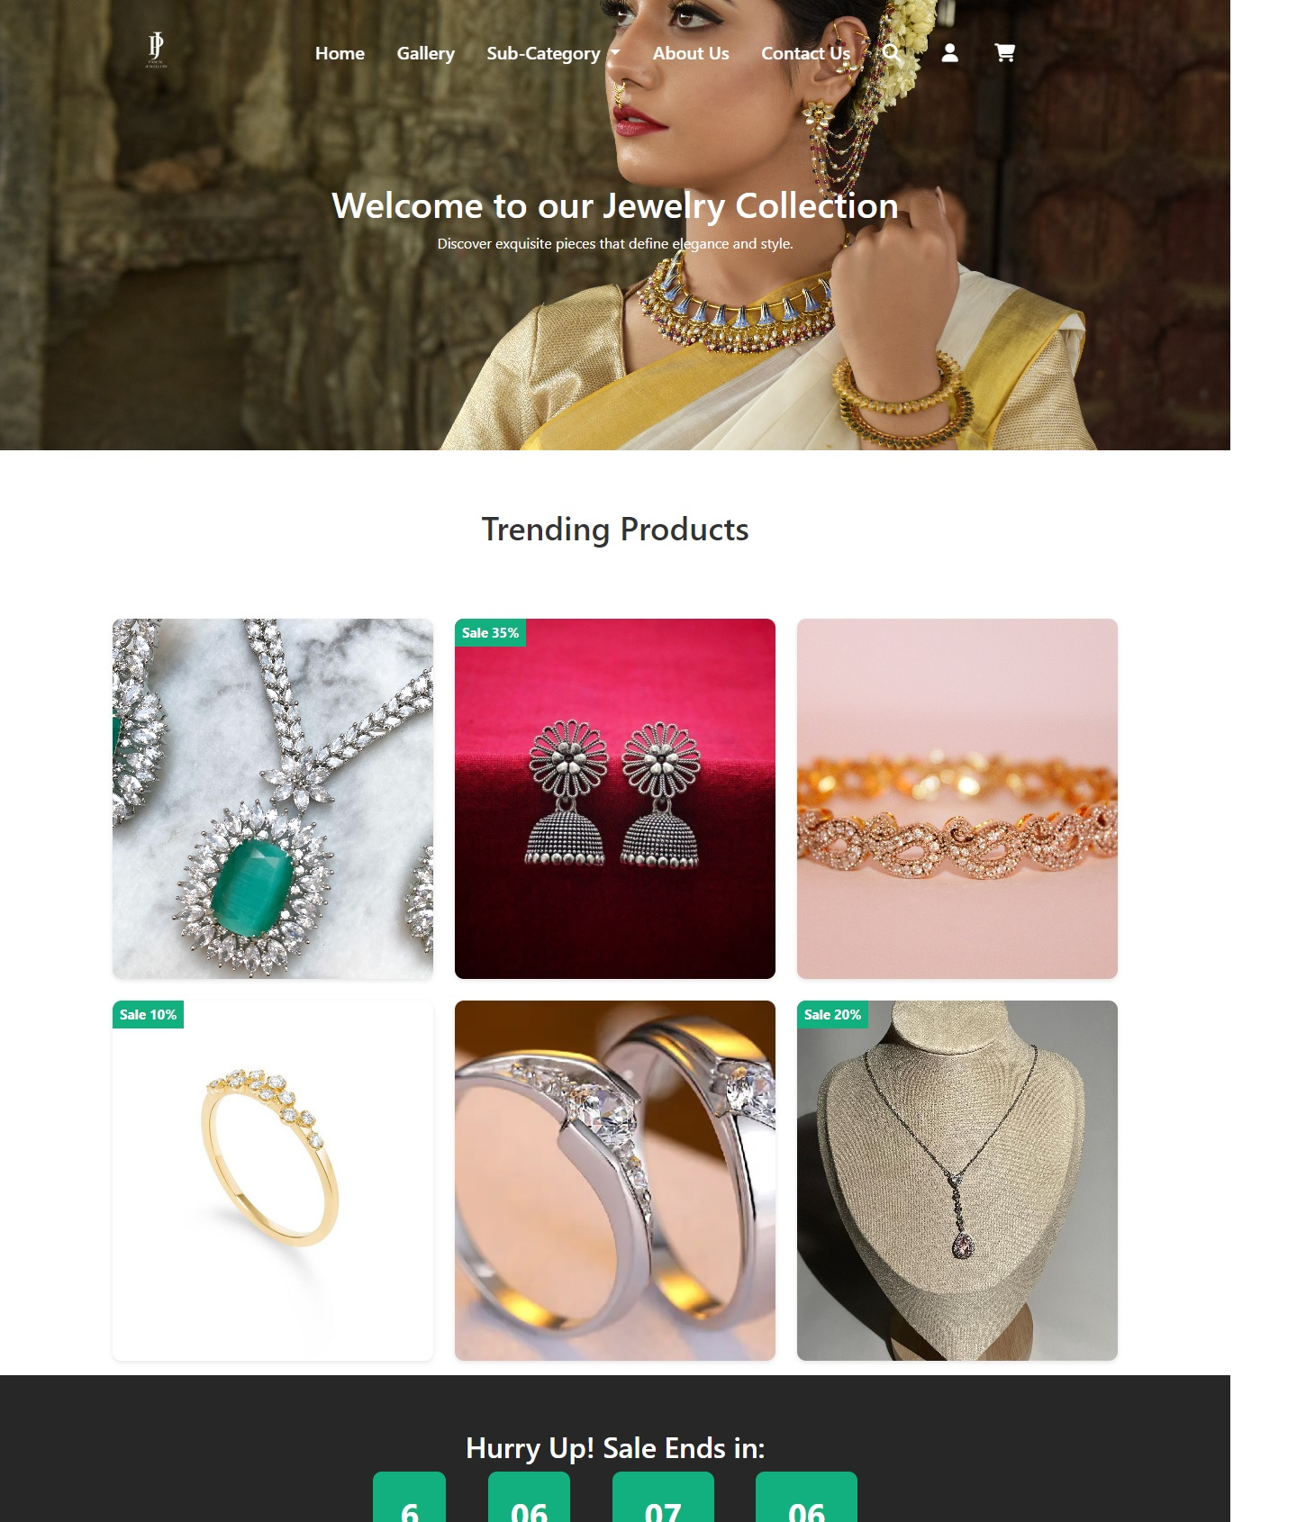

Description: The "Gallery" link provides access to a collection of stunning images showcasing our jewellery products.

Usage: Users can explore our jewellery designs and get inspired by visiting the gallery.

**Categories (Dropdown)**

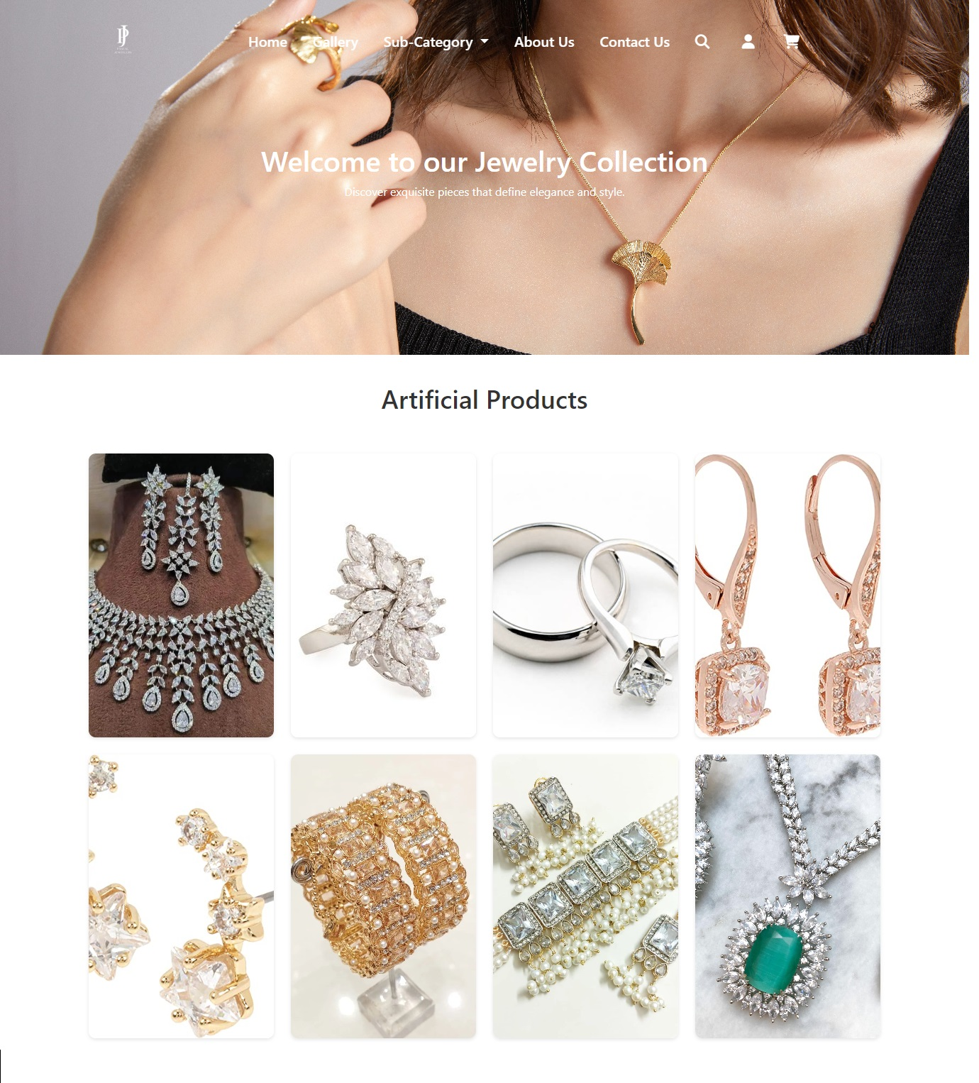

Description: The "Categories" dropdown menu provides access to two main categories: "Original" and "Artificial."

Usage: Users can hover over this menu to reveal the sub-categories and click on them to explore specific product collections.

**About Us**

Description: The "About Us" link directs users to a page where they can learn more about Pascal Jewellers, our story, and our mission.

Usage: Users interested in our background and values can visit the "About Us" page.

**Contact Us**

Description: The "Contact Us" link allows users to reach out to us for inquiries, feedback, or support.

Usage: Users can access the contact form or find our contact details for inquiries.

**Search Bar**

Description: The search bar icon, represented by a magnifying glass, allows users to initiate a search for specific products or information.

Usage: Clicking on the magnifying glass icon opens a search input field where users can enter keywords to search the website.

**User Icons (Account, Cart)**

Description: The user icons include an account icon and a shopping cart icon.

Usage: Users can click on the account icon to access their account details or log in, and they can click on the cart icon to view and manage items in their shopping cart.

Shopping Cart:

In the product detail document for Pascal Jewellers, there's a section titled "Add to Cart." This section provides a link that allows customers to add the product to their shopping cart. Here's how the shopping cart process works:

**Add to Cart Link:** When a customer clicks on the "Add to Cart" link in the product detail document, it initiates the process of adding the selected product to their virtual shopping cart.

**Shopping Cart Page:** Once the product is added to the cart, customers are redirected to a dedicated shopping cart page on the Pascal Jewellers website. This page provides an overview of the items in their cart.

**Cart Contents:** On the shopping cart page, customers can view the product they added, including its name, price, quantity, and a subtotal for that item. They can also see the total cost of all items in the cart.

**Quantity Adjustment:** Customers have the option to adjust the quantity of each item in their cart. They can increase or decrease the quantity of a particular product and see the updated subtotal.

**Checkout:** When customers are ready to make a purchase, they can proceed to the checkout page by clicking a "Checkout" button or link on the shopping cart page.

In summary, the shopping cart functionality allows customers to select and add products to their cart, review their selections, adjust quantities, and proceed with the purchase. It simplifies the online shopping experience and helps customers keep track of their selected items and their total cost.

Shopping User Account:

A shopping user account on the Pascal Jewellers website is a personalized and secure space for customers to manage their online shopping experience. It offers several key features and benefits:

**1. Registration and Login**

Customers can create a shopping user account by providing their email address and setting a password.

Registered users can log in securely using their credentials.

**2. Personalized Profile**

Upon registration, customers can fill in their profile details, including their name, shipping address, and contact information.

This information is securely stored and makes the checkout process faster and more convenient.

Footer:

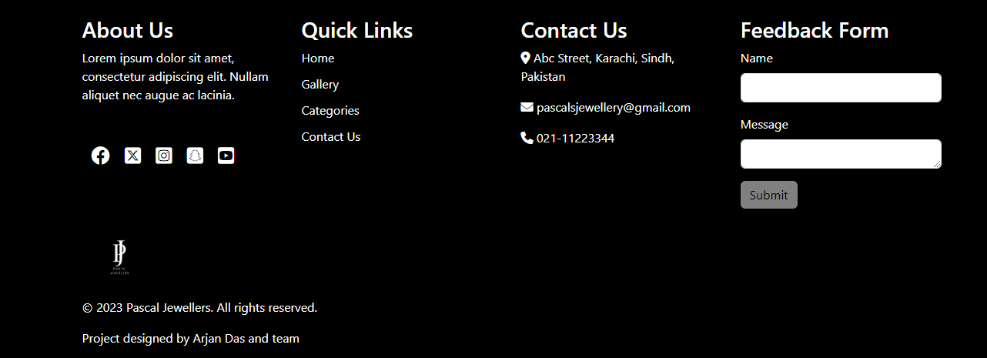

The footer section in the Pascal Jewellers website documentation serves as a valuable resource for additional information, contact details, and acknowledgments. Here's what you can find in the footer.

**1. About Us**

A brief introduction to Pascal Jewellers, providing a glimpse into the company's mission, values, and commitment to quality jewelry.

**2. Quick Links**

Direct links to essential website sections, including Home, Gallery, Categories, and Contact Us, for easy navigation.

**3. Contact Information**

Contact details for Pascal Jewellers, including:

Address: The physical location of the store (e.g., Abc Street, Karachi, Sindh, Pakistan).

Email: The official email address for inquiries and communication (e.g., pascalsjewellery@gmail.com).

Phone: The contact phone number for customer support (e.g., 021-11223344).

**4. Feedback Form**

A convenient feedback form that allows users to submit their comments, questions, or feedback directly to Pascal Jewellers. The form typically includes fields for:

Name: The user's name for personalization.

Message: A text area where users can type their feedback or inquiries.

Submit Button: A button to submit the form.

**5. Social Media Icons**

Links to Pascal Jewellers' social media profiles, including Facebook, Twitter, Instagram, Snapchat, and YouTube. Users can click these icons to visit and follow the brand's social media pages.

**6. Brand Logo**

The Pascal Jewellers brand logo, displayed at the bottom of the footer, provides brand recognition and a sense of professionalism.

**7. Copyright Information**

Copyright information indicating that all rights are reserved for Pascal Jewellers in the specified year (e.g., © 2023 Pascal Jewellers). The footer is a crucial section that not only provides essential contact information but also reinforces the brand's identity, social media presence, and commitment to customer engagement and feedback.

## How to Use the Website

To use the Pascal Jewellery website, simply visit the website in your web browser. You can browse the product catalog by category or use the search engine to find specific products. Once you have found a product that you are interested in, you can view more information about the product, add it to your wish list, or add it to your shopping cart.

If you are not logged in to the website, you will be prompted to do so before you can proceed to checkout. Once you are logged in, you can enter your shipping and billing information and choose a payment method. Once you have completed your purchase, you will receive a confirmation email.

## Additional Information

The Pascal Jewellery website is secured with an SSL certificate to protect your personal and financial information. The website also uses cookies to provide you with a better user experience. You can learn more about the website's privacy policy and cookie policy in the footer of the website.